创建一个项目vue-ssr-tech；

Mkdir vue-ssr-tech

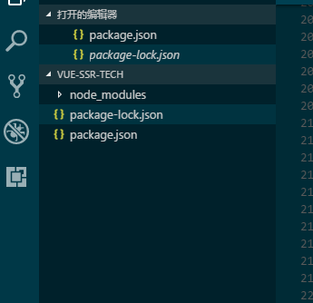

打开根目录

Npm init yes

生成一个package.json

npm i webpack vue vue-loader

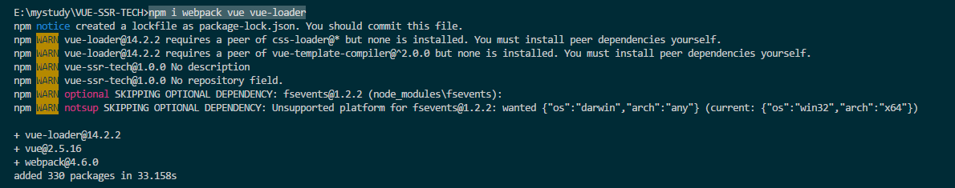

npm notice created a lockfile as package-lock.json. You should commit this file.

npm WARN vue-loader@14.2.2 requires a peer of css-loader@* but none is installed. You must install peer dependencies yourself.

npm WARN vue-loader@14.2.2 requires a peer of vue-template-compiler@^2.0.0 but none is installed. You must install peer dependencies yourself.

npm WARN vue-ssr-tech@1.0.0 No description

npm WARN vue-ssr-tech@1.0.0 No repository field.

npm WARN optional SKIPPING OPTIONAL DEPENDENCY: fsevents@1.2.2 (node_modules\fsevents):

npm WARN notsup SKIPPING OPTIONAL DEPENDENCY: Unsupported platform for fsevents@1.2.2: wanted {"os":"darwin","arch":"any"} (current: {"os":"win32","arch":"x64"})

+ vue-loader@14.2.2

+ vue@2.5.16

+ webpack@4.6.0

added 330 packages in 33.158s

缺少两个依赖（pee）

npm i css-loader vue-template-compilerr

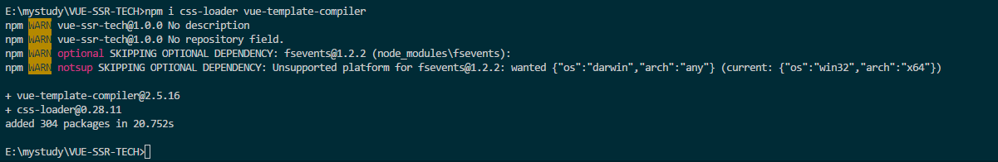

npm WARN vue-ssr-tech@1.0.0 No description

npm WARN vue-ssr-tech@1.0.0 No repository field.

npm WARN optional SKIPPING OPTIONAL DEPENDENCY: fsevents@1.2.2 (node_modules\fsevents):

npm WARN notsup SKIPPING OPTIONAL DEPENDENCY: Unsupported platform for fsevents@1.2.2: wanted {"os":"darwin","arch":"any"} (current: {"os":"win32","arch":"x64"})

+ vue-template-compiler@2.5.16

+ css-loader@0.28.11

added 304 packages in 20.752s